Ideation Phase
Empathize & Discover
Date | 25-06-25
Team id | LTVIP2025TMID47835
Project name | Resolver
marks | 4 marks
Empathy Map Canvas:
An empathy map is a simple, easy -t o- digest visual that captures knowledge about a user’s
behaviours and attitudes.
It is a useful tool to help teams better understand their users.
Creating an effective solution requires understanding the true problem and the person who is
experiencing it. The exercise of creating the map helps participants consider things from the
user’s perspective along with his or her goals and challenges.
Example:
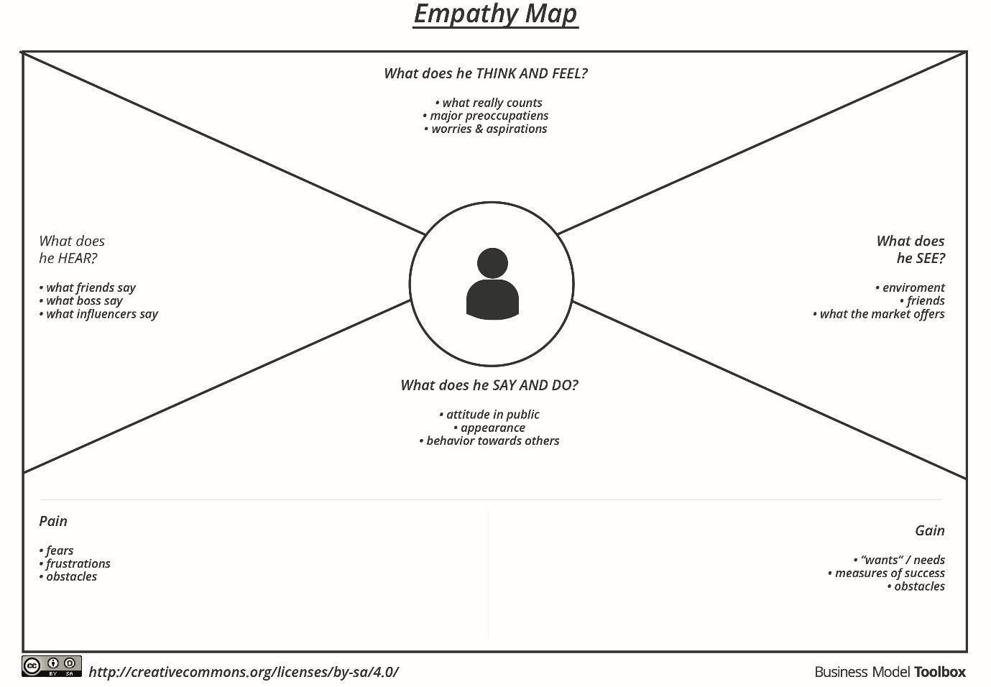
Reference: https://www.mural.co/templates/empathy -map -canvas
Example: Resolve Now
